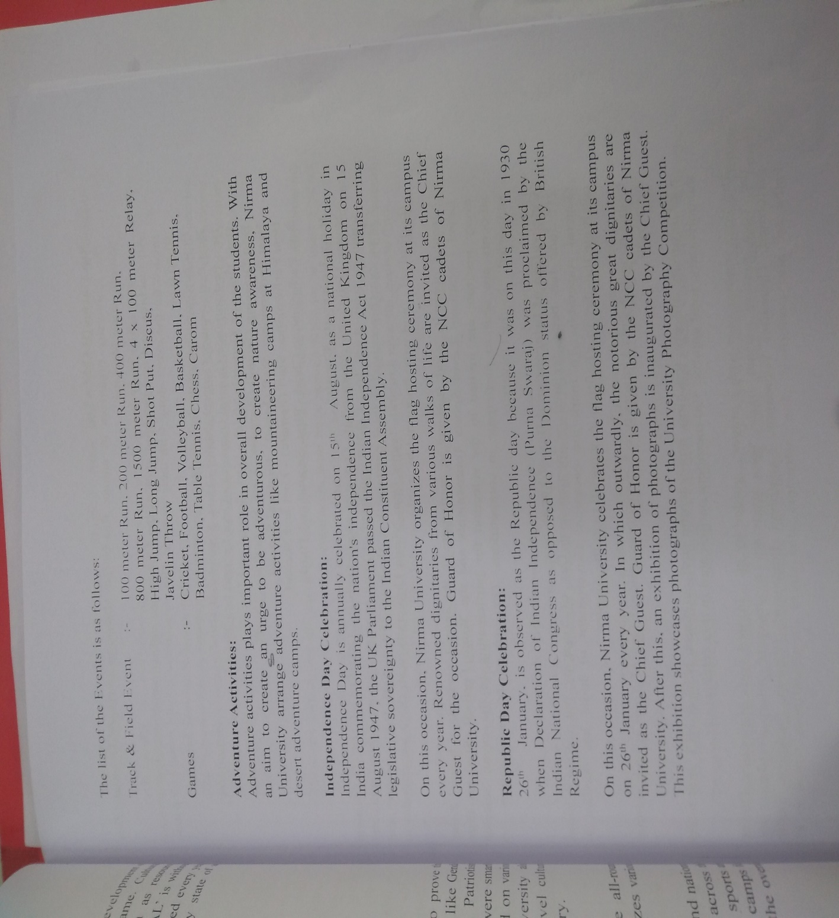He is the cow. The cow is a successful animal. Also he is 4 footed, And because he is female, he give milks, (but will do so when he is got child). He is sacred to Hindus and useful to man. But he has got four legs together. Two are forward and two are afterwards. His whole body can be utilized for use. More so the milk. Milk comes from 4 taps attached to his basement. (Horses don't have any such attachment) What can it do? Various ghee, butter, cream, curd, why and the condensed milk and so forth. Also he is useful to cobbler, watermans and mankind generally. His motion is slow only because he is of lazy species. Also his other motion. (gober) is much useful to trees, plants as well as for making flat cakes (like Pizza), in hand , and drying in the sun. Cow is the only animal that extricates his feeding after eating. Then afterwards she chew with his teeth whom are situated in the inside of the mouth. He is incessantly in the meadows in the grass.  
His only attacking and defending organ is the horns, specially so when he is got child. This is done by knowing his head whereby he causes the  
weapons to be paralleled to the ground of the earth and instantly proceed with great velocity forwards. He has got tails also, situated in the  
backyard, but not like similar animals. It has hairs on the other end of the other side. This is done to frighten away the flies.  
The palms of his feet are soft onto the touch. So the grasses head is not crushed. At night time have poses by looking down on the ground and he shouts. His eyes and nose are like his other relatives. This is the cow...

B)

